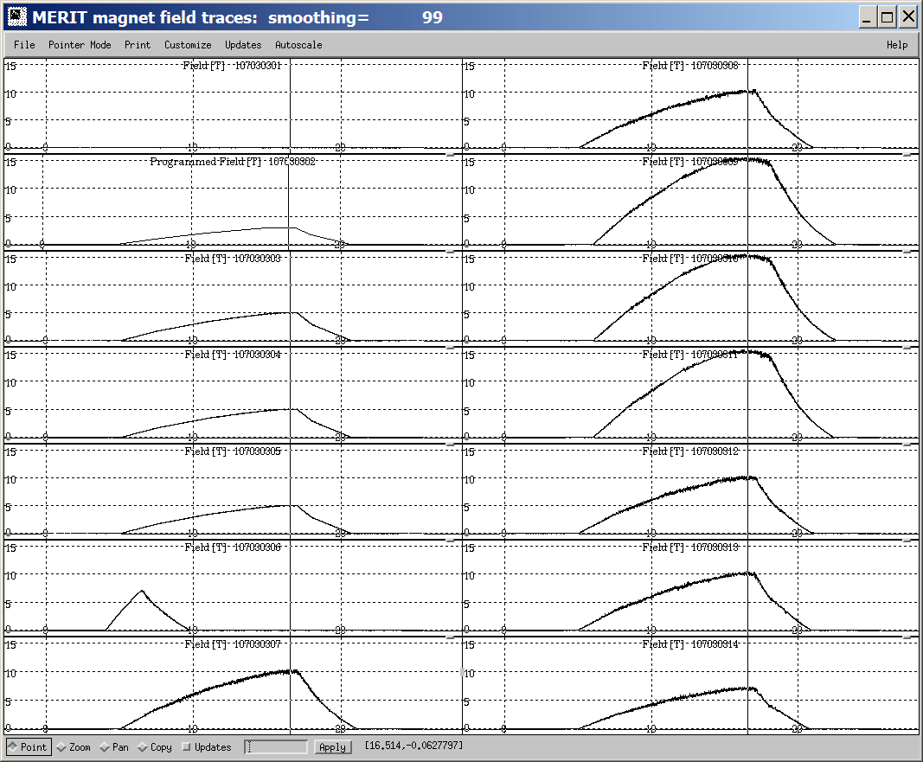
The trigger for the MERIT magnet pulses was generated at time zero for all traces. The recorded data for run 107030302 was somehow not stored, which accounts for the plot title “Programmed Field.” The vertical line running through all traces shows the t = 16.5 s time point.

