Report No. 203-HJT-9013 Draft

MERIT Target System

Operating Manual

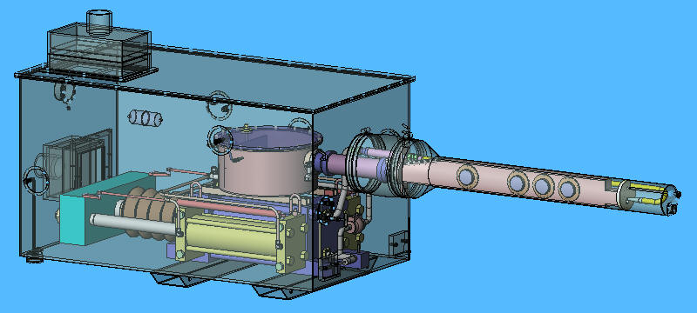

Van B. Graves
Philip T. Spampinato

February 2007

MERIT Target System Operating Manual

Van B. Graves
Philip T. Spampinato

DISCLAIMER
This report was prepared as an account of work sponsored by an agency of the United States Government. Neither the United States government nor any agency thereof, nor any of their employees, makes any warranty, express or implied, or assumes any legal liability or responsibility for the accuracy, completeness, or usefulness of any information, apparatus, product, or process disclosed, or represents that its use would not infringe privately owned rights. Reference herein to any specific commercial product, process, or service by trade name, trademark, manufacturer, or otherwise, does not necessarily constitute or imply its endorsement, recommendation, or favoring by the United States Government or any agency thereof. The views and opinions of authors expressed herein do not necessarily state or reflect those of the United States Government or any agency thereof.
Oak Ridge National Laboratory is managed by UT-Battelle, LLC, under contract DE-AC05-00OR22725 for the U.S. Department of Energy.
Table of Contents
I. Introduction 1
II. Hazards 2
III. System Operation 3
Configuration 4
Operation 5
Performance 6
System Messages 7
Sensors and Alarms 7
IV. Modifying Configuration Settings 8
V. Log Files 11
VI. System Alerts 12
VII. Spill Cleanup 14

Introduction
The purpose of this document is to provide operating instructions for the Mercury Intense Target (MERIT) Hg target control system. It assumes the equipment comprising the Hg system has been installed and set up per the procedures in the MERIT Installation Manual.
The Hg delivery system is comprised of two primary components – a hydraulic power unit (HPU) and a syringe pump which creates a 1-cm-dia jet of Hg. Nominal jet velocity is 20 m/s. The jet is formed inside a 15 Tesla magnetic field, and high-speed optics are used to capture the interaction between the jet and a proton beam.
The HPU consists of
- 30 hp motor
- 4000 psi/ 12.9 gpm pump with over-pressure relief valve set at 3200 psi
- 40 gal reservoir with Quintolubric-888 vegetable-oil-based hydraulic fluid
- Power controls
- National Instruments Labview control system hardware
The two hydraulic hoses are connected to dual drive cylinders on the syringe pump. The drive cylinders are rated for 200 bar and have been pressure tested to 300 bar. Hydraulic fluid flow rate during a 20m/s jet will be approximately 8.7 liter/min.
The Hg cylinder is rated for 100 bar, and the fluid pressure is given by the flow resistance in the Hg nozzle piping and magnetohydrodynamic effects due to the magnetic field. Hg cylinder velocity during a 20m/s jet is approximately 1.3 cm/s.
During operations at CERN, only the syringe cylinders and secondary containment will be located in the TT2A tunnel; the HPU and control system hardware will be located in TT2. Hydraulic hoses, electrical sensor cables, and optical fiber bundles pass through holes in the wall between the two tunnels. Sensors terminate at the labview hardware inside the HPU cabinet. The labview hardware communicates with a control computer through an Ethernet connection; this allows the system operator to be located in a remote control room during the experiment.
Emergency stop buttons within the control room can be used to remove electrical power from the Hg delivery system should an abnormal event occur. Should network connectivity from the control computer to the labview hardware occur, the labview controller is configured to leave the Hg system in a safe state and prevent movement of the syringe cylinders.

Hazards
The most obvious hazard in the MERIT experiment is the use of elemental Hg as the jet fluid. Once Hg is filled into the primary containment, however, it is a closed system and will not present itself as a personnel hazard unless an abnormal condition occurs. During the fill and drain operations, the potential for exposure to Hg vapors is at its highest level, and at the conclusion of the experiment, the complication of handling slightly activated fluid is added. Procedures for all Hg handling operations have been developed to minimize potential exposure.
The MERIT hydraulic system operates using 460V in the U.S. and 380V in Europe, so care should be taken during connecting or disconnecting electrical power to the system. The electrical control box has interlocks to disengage power when the cabinet is opened, and under normal conditions there will be no need to open the electrical control box.
Dual hydraulic cylinders provide the force required to expel the Hg from its cylinder, and standard industrial hazards for hydraulic systems are present. The design pressure for the Hg is 100 bar, but the hydraulic system operating pressure is 200 bar. All hoses and fittings have been selected to accommodate these pressures.

System Operation
The operator controls the Hg system through a Labview program. The operator interface is shown in Figure 1. The control system communicates with the HPU and syringe sensors through an Ethernet interface which allows the operator to be stationed well outside the experimental area. The basic sequence of events expected for each beam pulse (and associated Hg jet) is as follows:
- Configure the desired jet velocity profile
- Power up the HPU and extend the syringe to fill the Hg cylinder
- Set the system in a “wait” mode looking for the pre-beam trigger
- Syringe will automatically start based on the user-input velocity profile
- Examine data log for correct operation and copy syringe data into Excel spreadsheet template for later review
The MERIT Control System is started by running Labview and opening the "MERIT Control System.vi" file. This will open the control system file and display the operator interface, which is shown in Figure 1. To start the control system, use the run icon on the top of the Labview window – it looks like an arrow. Should a software problem occur which the control system cannot correct, the Labview vi can be terminated using the stop icon at the top of the window.
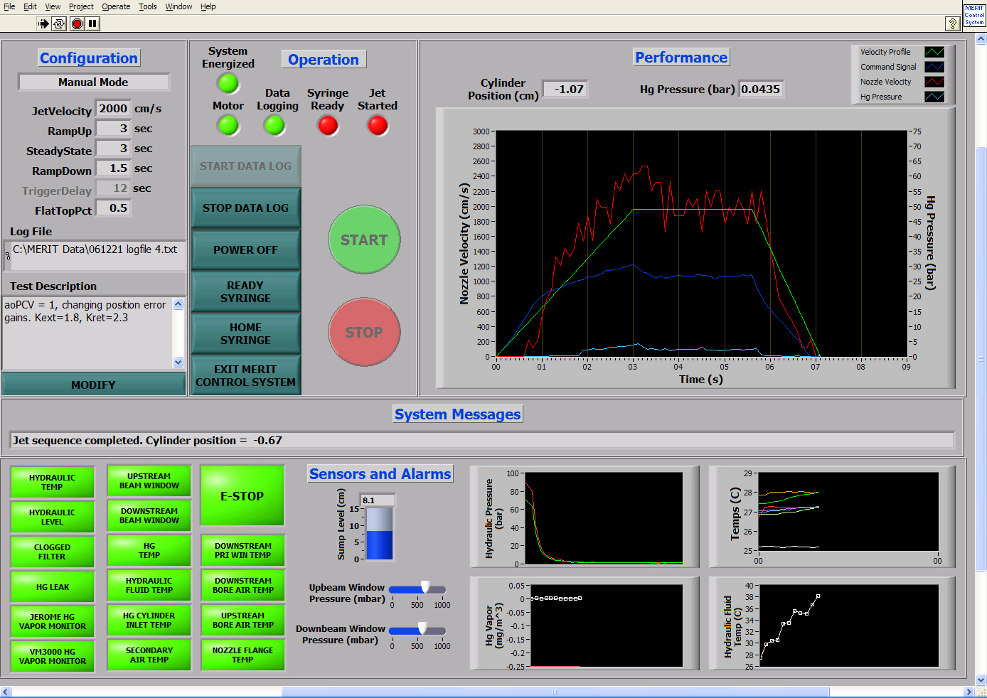
Figure 1. MERIT Hg System Operator Interface
The control system operator interface is divided into five sections, and these are discussed below.

Configuration
This section displays the current jet velocity profile settings and log file information. The user cannot directly change the data on the main control screen; the Modify button brings up a separate window that allows the profile to be changed along with the sensor alarm information. Details of the configuration modification window are described in Section IV, but the relevant information displayed on this main control screen include the following:
Mode: either Manual or Triggered. In Manual mode operation, the user controls when syringe acceleration begins; in Triggered mode, a digital input to the control system starts a timer and delays syringe acceleration such that the desired steady-state velocity will be reached prior to the expected beam pulse.
Jet Velocity: desired steady-state velocity of the Hg jet.
RampUp: nominal duration of the acceleration phase of the velocity profile.
SteadyState: nominal duration of the steady-state phase of the velocity profile.
RampDown: nominal duration of the deceleration phase of the velocity profile.
TriggerDelay: time from the receipt of the trigger to the beam pulse. Only applicable during Triggered mode operations.
FlatTopPct: percentage of the constant-velocity section of the velocity profile at which the beam pulse is expected.
Log File: filename containing sensor and operational data. Can accommodate data from multiple runs.
Test Description: user-input text associated with a particular syringe run intended to describe test conditions such as beam configuration, magnet field strength, etc.
Modify: used to modify configuration parameters.
As an example of a Triggered-mode test, suppose a steady-state jet is desired for 4 seconds, and the profile should be timed such that the beam pulse occurs after 3 seconds of steady-state operation. In addition, the time from the trigger to the pulse is 20 seconds, steady-state velocity of 2000cm/s should be reached in 5 seconds, and deceleration should occur in 1 second. System should be configured as follows:
Mode: Triggered
Jet Velocity: 2000
RampUp: 5
SteadyState: 4
RampDown: 1
TriggerDelay: 20
FlatTopPct: 0.75
Using these input values, once a trigger pulse is received, syringe acceleration will begin at t=20 – (5 + 0.75*4) = 12 seconds.

Operation
The buttons in this section control the syringe hydraulic power unit, or HPU, and provide various indicator lights. Normal shutdown of the control system is also performed in this section.
Provided indicator lights include
System Energized: Indicates electrical and control panels are energized and the system is not in e-stop mode. If either the local or pendant-mounted e-stop buttons are pressed, then the System Energized light will be be energized.
Motor: Indicates HPU motor is running. Controlled by Power On/Off button.
Data Logging: Indicates whether history/log data is being written to a log file. Controlled by Start/Stop Data Log buttons.
Syringe Ready: Indicates Hg cylinder and supply piping have been filled and system is ready to provide jet according to configuration data. Controlled by Ready Syringe button.
Jet Started: Controlled by the Start button, the meaning of the indicator depends on the current Mode setting. In Manual mode, it indicates jet velocity profile has been started; in Triggered mode, it indicates the system is awaiting receipt of a trigger signal.
Button controls include
Start Data Log: Enables data logging into the log file specified in the configuration settings. More information regarding data logging is contained in Section V.
Stop Data Log: Disables data logging.
Power On/Off: Turns the HPU pump motor off and on. While the pump has an integrated fluid cooler and should be able to run indefinitely, it is usually good practice to power off the HPU during the magnet cool-down process. In addition, it has been observed that frequent power off/power on cycles can overheat the coils in the motor contactors such that they will not start the motor until they cool down.
Ready Syringe: Prepares the syringe for producing a Hg jet according to the parameters specified in the configuration settings. Based on the velocity profile, the system calculates the volume of Hg required to pre-fill the Hg supply piping and subsequently produce the desired jet. The control system commands the syringe to extend far enough to draw this volume of Hg into the cylinder. It delays for one second, then slowly fills the supply piping to the nozzle. This is to minimize any shock caused by a surge of Hg.
Home Syringe: The control system commands the syringe to slowly move the fully retracted position, designated as the zero position. The syringe should be moved to the Home position prior to any lifting or transporting.
Exit MERIT Control System: Closes any open files, powers off the HPU, and exits the control system.

Performance
This section of the interface provides visual feedback regarding the performance of the syringe during a jet creation sequence. Digital indicators provide syringe position and Hg pressure at all times. Note that the positive syringe direction is given by movement from fully extended to fully retracted. The syringe zero (or Home) position occurs when the cylinders are fully retracted; thus all syringe positions will be negative values.
The chart displays real-time data during a jet creation. Four data streams are plotted: the nozzle velocity profile, the command signal sent to the proportional control valve, the Hg pressure in the cylinder discharge piping, and the calculated nozzle velocity. The X-axis is the time axis and will automatically rescale itself based on the configuration parameters provided by the user. Two Y-axes are provided; the left axis is the nozzle velocity (provided by calculating the cylinder velocity using data from the cylinder position sensor), and the right axis is the Hg pressure (provided by a sensor in the Hg cylinder discharge piping). The velocity profile and the command signal are scaled to match the Nozzle Velocity axis.
During a jet creation, a vertical line is provided at the expected time of the beam pulse. It does not represent any type of electrical signal, but is calculated based on the configuration data.
If data logging is enabled, all data shown in the chart is logged to the data file when cylinder motion stops.

System Messages
In this section, status messages are provided to the operator by the control system software. No user input or editing is permitted.

Sensors and Alarms
This section provides graphs of sensor data including Hg vapor levels, various temperatures, hydraulic pump pressures, and sump tank level. Descriptions of these alarms as well as remediation actions to be taken are provided in section VI.

Modifying Configuration Settings
User-defined parameters within the MERIT control system are configured within the window shown in Figure 2. Descriptions of each parameter are given below.
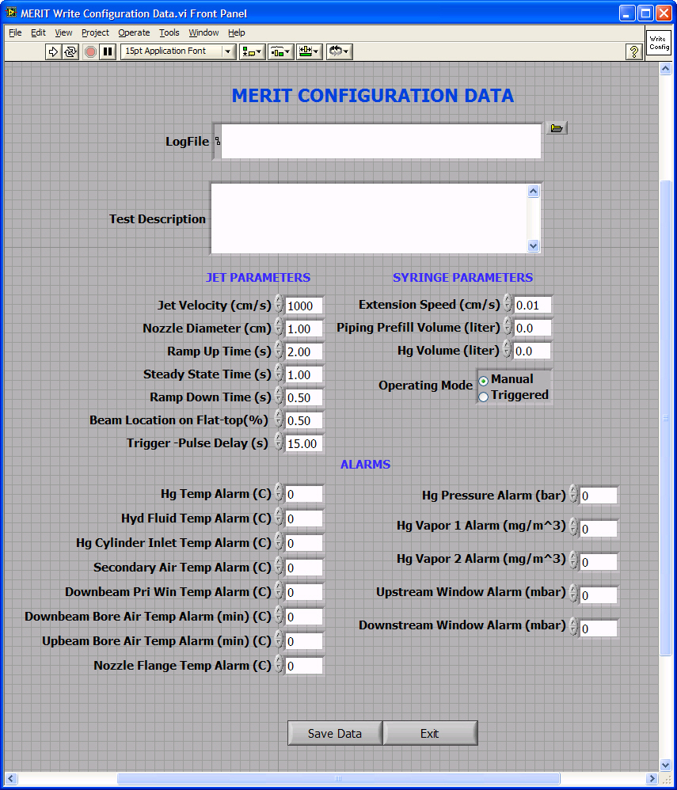
Figure 2. Modify configuration screen
LogFile: File containing history and sensor data of a MERIT session. All user interactions and syringe data are logged to this file when the user enables data logging.
Test Description: Text field provided to allow user to document data associated with a particular log file, such as beam parameters or run number. This field is included in the LogFile.
Jet Parameters
Jet Velocity: Desired steady-state jet velocity in cm/sec.
Nozzle Diameter: Actual inner diameter (cm) of nozzle tip. This parameter is used to calculate flow areas so as to obtain accurate jet velocities.
Ramp Up Time: Duration (sec) of the nominally constant acceleration portion of the desired jet velocity profile. As this value decreases the Hg flow places more impact forces on the Hg piping as air is expelled from the nozzle. Ramp up durations greater than 2 sec are recommended.
Steady State Time: Duration (sec) of the steady-state portion of the desired jet velocity profile. The peak magnetic field and the beam pulse should both occur during this portion of the profile. Testing has shown actual constant velocity of the syringe usually takes approximately 1 sec once the steady-state phase is entered.
Ramp Down Time: Duration (sec) of the nominally constant deceleration portion of the desired jet velocity profile. Making this value too small may cause the syringe cylinders to stop too quickly and allow separation of the Hg flow to occur, which could cause a hammer effect within the piping. A minimum recommended value for this parameter is 1 sec.
Beam Location on Flat-top: Compared to the duration of the beam pulse, the duration of the jet’s constant velocity is extremely long. This parameter controls when the beam pulse should occur relative to the start of the constant velocity portion of the profile. It is given as a number between 0 and 1. It is only applicable during Triggered mode operations.
Trigger-Pulse Delay: Time (sec) between when the pulse warning trigger is received by the control system and the actual pulse arrives. This parameter controls the start of the acceleration phase so that the beam pulse occurs at the specified percentage of the flat portion of the velocity profile. It is only applicable during Triggered mode operations.
Syringe Parameters
Cylinder Fill Speed: Command velocity (cm/sec) given to the syringe cylinders to fill the Hg cylinder with fluid.
Piping Prefill Volume: Volume of fluid (liter) required to fill the Hg supply piping prior to the start of a jet. The control system slowly retracts the syringe during the Ready Syringe operation to pre-fill the piping so as to minimize any shock effects during acceleration. This parameter adds to the distance the cylinders move during the fill operation.
Hg Volume: Amount of Hg (liter) loaded into the syringe sump tank. The control system uses this value to warn the operator if the volume of liquid needed to produce the desired jet velocity profile exceeds the quantity available.
Operating Mode: Either Manual or Triggered. In Manual mode, the Start button initiates the desired jet velocity profile immediately. In Triggered mode, the jet velocity profile is delayed such that the beam pulse occurs at the specified percentage of the profile’s steady-state duration.
Alarms
Temperature Alarms: Unless otherwise specified, the temperature alarms are set whenever the particular RTD reading is equal to or greater than the specified set point.
Hg Pressure: This alarm is set if the Hg fluid pressure in the cylinder discharge piping meets or exceeds the specified set point.
Hg Vapor: These alarms are set if either of the Hg vapor monitor readings meet or exceed the specified set point.
Upstream/Downstream Windows: These alarms are set if the pressure in either window drops below the specified set point.

Log Files
The MERIT Control System has the capability to log user operations and sensor data. Logging is controlled by a button in the Operation section of the interface. The log file name is user-specified, and the user also controls how many syringe cycles are included in a given file. The user can input some descriptive text associated with a single cycle or a series of cycles.
The log file is essentially a history file that records all user operations so a complete archive of a syringe cycle is recorded. The Labview application must be running in order for data logging to be operational. During the time a jet is created, syringe data is logged several times per second and includes system pressures and jet velocity information. Whenever the syringe is idle, such as during the magnet cooling cycle, environmental data such as Hg vapor levels and system temperatures are logged at a frequency of once per minute.
All syringe and sensor data is written in a tab-delimited format as a convenience for incorporating into an Excel spreadsheet. An Excel template is provided that includes automatic data plots, so a simple copy-and-paste operation is all that’s required to take data from the log file into an Excel chart.
Should the operator neglect to enable data logging prior to a syringe cycle, the control system maintains a complete history log of all operations which can be used as a backup. It is not recommended that this file be used as the only log file. The location of this file is C:\MERIT Data\MERIT Control System\systemlogfile.txt.

System Alerts
Indicators are provided to alert the operator to unusual conditions based on sensor input. Some of these alarms are based on user-provided configuration data, while others are digital inputs to the National Instruments’ Labview hardware. These alerts include
Hydraulic Temp: The hydraulic pump system has a fluid temperature sensor that will shut down the pump motor should the fluid temperature exceed the setpoint. Forcing fluid through the proportional control valve increases its temperature. The hydraulic system incorporates a fluid cooling system to aid in heat removal.
Hydraulic Level: Should the hydraulic fluid level in the reservoir fall below a certain level, this indicator will be set, and the hydraulic system will automatically power itself off to protect the pump.
Clogged Filter: The low-pressure side of the proportional valve incorporates a fluid filter with a sensor that detects when the filter needs replacement.
Hg Leak: A float switch is built into the bottom of the secondary containment box to detect major fluid leaks (either Hg or hydraulic fluid).
Hg Vapor Monitors: The readings from the vapor monitors are compared to their user-configured alarm setpoints. If one of those setpoints is exceeded, the corresponding alarm indicator is set.
Beam Windows: The secondary beamwindows were designed to form a chamber, and the interior of that chamber is slightly pressurized (few millibar gauge). Pressure gauges monitor the chamber pressure and the alarm is set if the pressure falls below the setpoint for either window.
Temperatures: The secondary box houses eight RTD’s to monitor temperatures within the box. In seven of those cases, the corresponding alarm is set if the temperature exceeds the user-configured setpoint. The magnet bore temperature sensor monitors the air temperature inside the target snout near the service end of the magnet. Should the sensor read a temperature below the setpoint, it will indicate the magnet bore heater is not functioning correctly, and this alarm will be set.
E-Stop: This indicator is set should one of the two emergency-stop buttons be pressed. One button is mounted on the HPU control panel, and one is pendant mounted. Should either e-stop buttons be pressed, electrical power to the 24V portion of the HPU is removed. The Hydraulic Temperature and Hydraulic Level indicators will illuminate in this condition because they are normally closed switches.
Should one of these alarm indicators show an unexpected condition, instructions are provided in Table 1 to aid in rectifying the condition. These instructions serve as guidelines, so discretion should be included in their use.
Table 1. System Alarm Responses
Alert | Recommended Response
Hydraulic Temperature | Hydraulic system will automatically shut down until fluid temperature falls below set point. Cannot be overridden.
Hydraulic Level | Hydraulic system will automatically shut down if fluid level in reservoir falls below set point. Inspection of hydraulic system is required.
Clogged Filter | Observe hydraulic system pressures. If condition persists, hydraulic filter should be changed.
Hg Leak | Note sump tank level and try to verify loss of fluid; Hg leak sensor can also be triggered by a hydraulic fluid leak. Note vapor levels and look for increase. Visual inspection may be required.
Hg Vapor Monitors | Jerome vapor monitor reads every 5 minutes, whereas the VM3000 is a continuous instrument. Beam window sensors will indicate any failure of the secondary beam windows. Check sump tank level to see if a major leak has occurred. Verification of Hg vapor in secondary containment can be completed by switching the sensor connected to the secondary containment with the Hg vapor sensor for the tunnel.
Beam Windows | Alarm indicates loss of pressure in a secondary beam window chamber. Log data should be reviewed to see if an abrupt change (indicating a window failure) or a gradual pressure loss (indicates leak) has occurred. If failure is indicated, visual verification is needed. If slow loss is indicated, re-pressurization is needed.
Temperatures | The sensor location and sensor log should be reviewed to determine potential cause and resolution. Decision to halt or continue experiment should be made after monitoring other sensor information.

Spill Cleanup
In the event of a significant Hg leak inside the secondary containment in which liters of fluid are released from the primary containment, the following steps should take place:
- Syringe operations must cease. Verification of the fluid loss should be evident from the sump tank level sensor and very high vapor levels inside the secondary containment.
- Follow the procedure outlined in the MERIT Installation Manual to remove Hg from the secondary containment sump. Access to the Hg system will be determined by CERN health physics personnel.
Should a leak occur outside the secondary containment during experiment operations, the following actions should take place:
- Any personnel in the area should leave the immediate vicinity of the spill.
- Contact the appropriate personnel at CERN.
- Access to the equipment and mercury will be determined by CERN procedures. The use of portable Hg vapor monitor(s) will be required.
- Appropriate PPE (anti-C suits, shoe covers, and gloves) will be required for spill cleanup. Mercury absorbent respirators will be required if vapor levels are above the Threshold Limit Value of 0.0125 mg/m^3 in the area.
- Mercury spill equipment will be brought into the area for cleanup.

